Containerization and Container Orchestration
MERN Application through Terraform and Ansible
Name: Nivedha S
ID: 13692
Date: 24nd Oct 2026

- Fork the repo and set remote url:
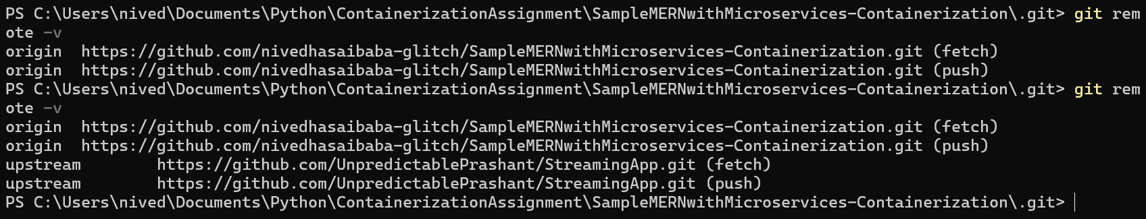
- Create a frontend & backend Dockerfile:
frontend:
FROM node:20-alpine AS build
WORKDIR /app
COPY package*.json ./
RUN npm ci
COPY . .
RUN npm run build
FROM nginx:alpine
COPY --from=build /app/build /usr/share/nginx/html
EXPOSE 80
CMD ["nginx", "-g", "daemon off;"]
backend:
FROM node:20-alpine
WORKDIR /app
ARG SERVICE_NAME
COPY ${SERVICE_NAME}/package*.json ./
RUN npm ci --omit=dev
COPY ${SERVICE_NAME}/ ./
ENV NODE_ENV=production
CMD ["npm", "start"]
- Build and test the images locally:
frontend:
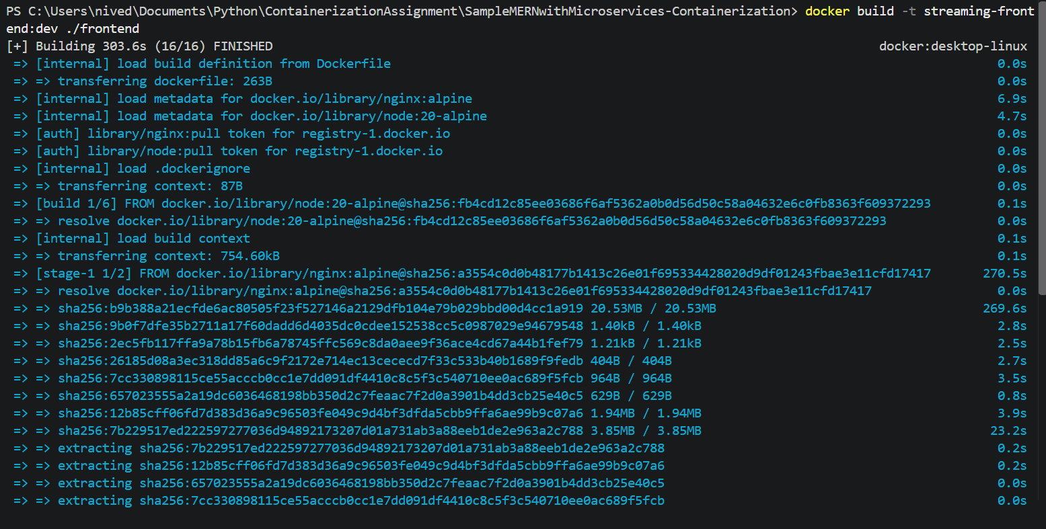
backend:
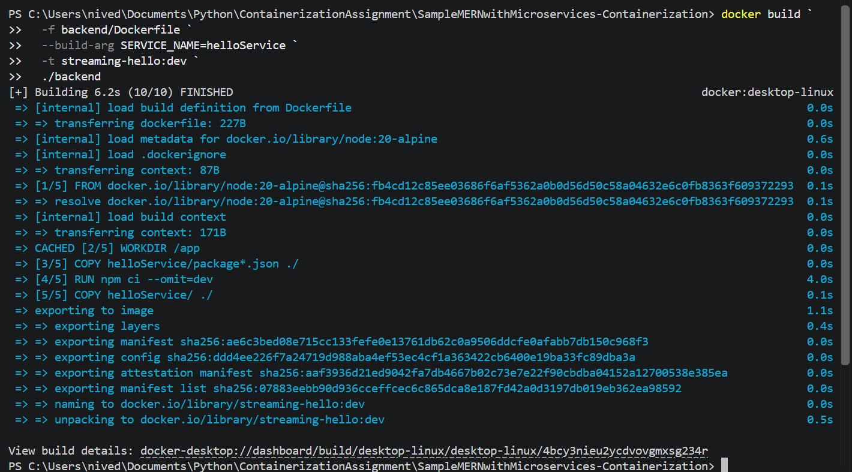
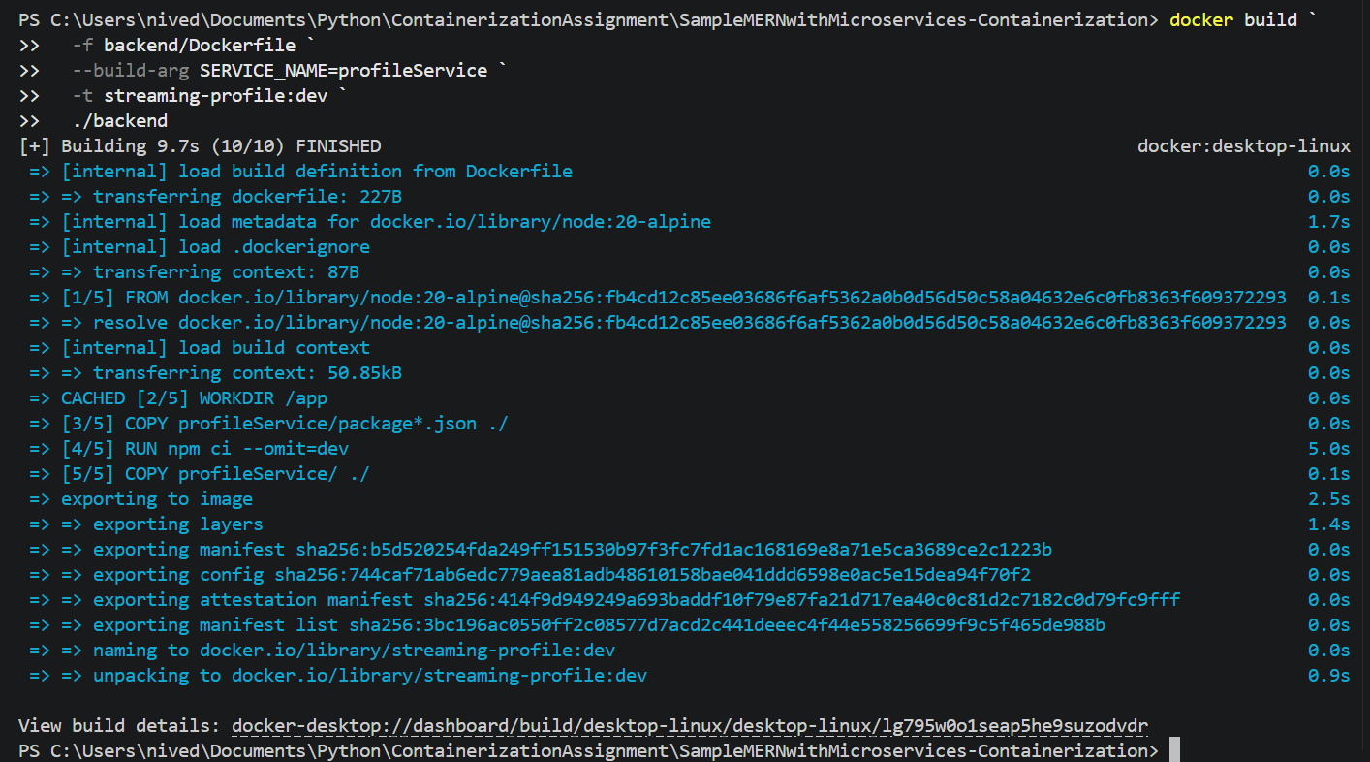
- Push your images to Amazon ECR:
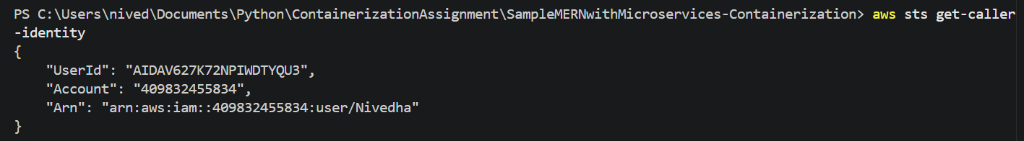
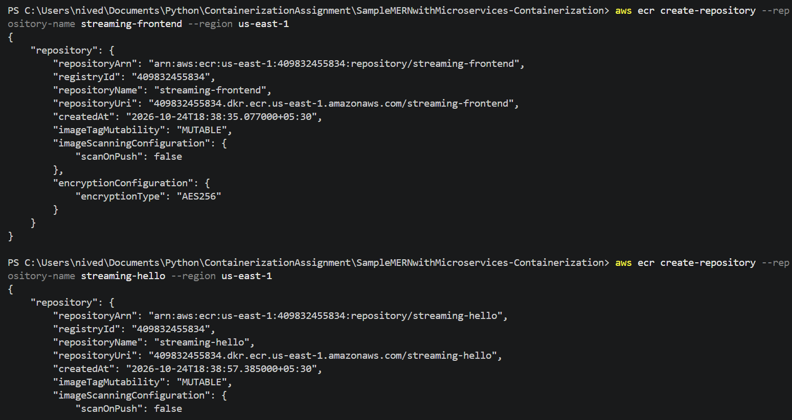
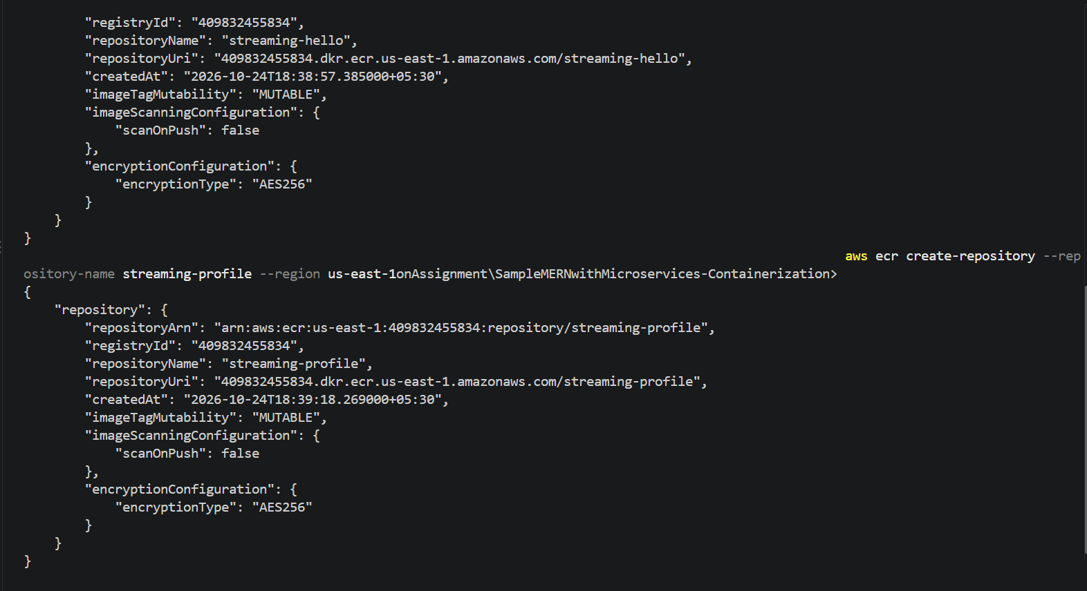
Tag and push all three images:
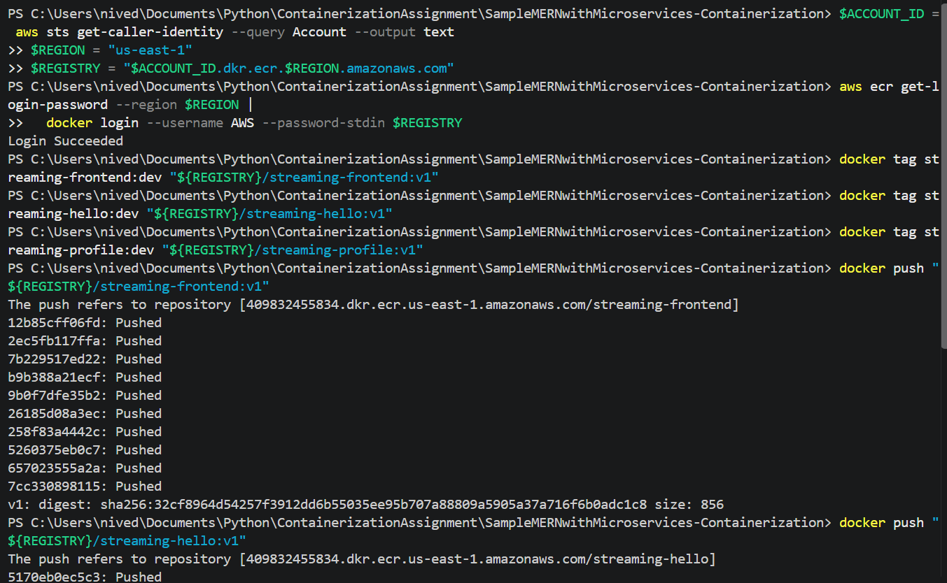
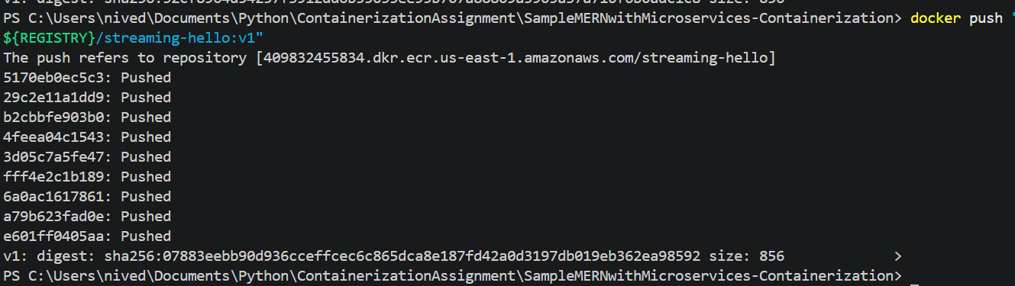
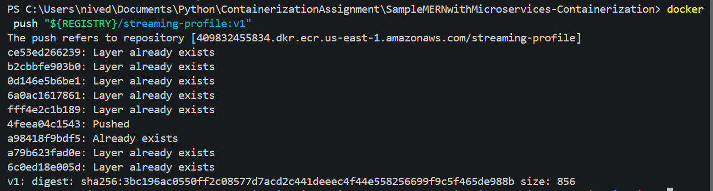
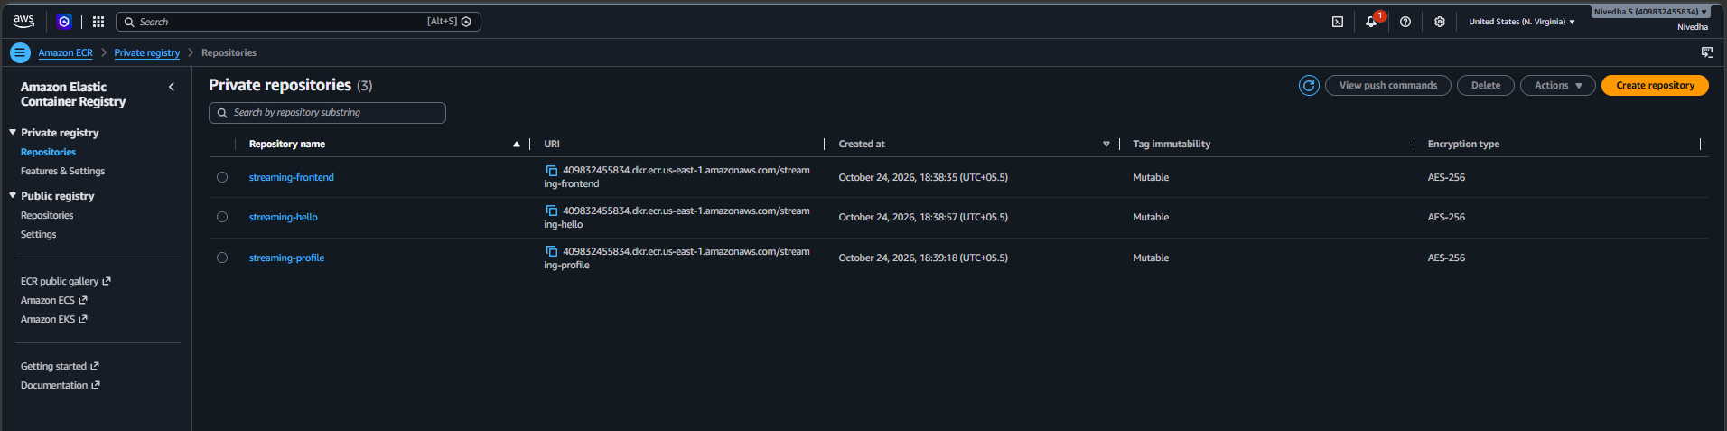
- Configure Jenkins jobs:
Jenkinsfile:
pipeline {
agent any

options {
timestamps()
disableConcurrentBuilds()
}

environment {
AWS_REGION = 'us-east-1'
FRONTEND_REPO = 'streaming-frontend'
HELLO_REPO = 'streaming-hello'
PROFILE_REPO = 'streaming-profile'
}

stages {
stage('Checkout') {
steps {
checkout scm
}
}

stage('Test') {
steps {
echo 'Checking application package files'

sh '''
set -eu
test -f frontend/package.json
test -f backend/helloService/package.json
test -f backend/profileService/package.json
'''
}
}

stage('Build Docker Images') {
steps {
sh '''
set -eu

docker build \
-t streaming-frontend:local ./frontend

docker build \
-f backend/Dockerfile \
--build-arg SERVICE_NAME=helloService \
-t streaming-hello:local ./backend

docker build \
-f backend/Dockerfile \
--build-arg SERVICE_NAME=profileService \
-t streaming-profile:local ./backend
'''
}
}

stage('Login to Amazon ECR') {
steps {
sh '''
set -eu

ACCOUNT_ID=$(aws sts get-caller-identity \
--query Account --output text)

REGISTRY="${ACCOUNT_ID}.dkr.ecr.${AWS_REGION}.amazonaws.com"

aws ecr get-login-password \
--region "$AWS_REGION" |
docker login \
--username AWS \
--password-stdin "$REGISTRY"
'''
}
}

stage('Push Images to ECR') {
steps {
sh '''
set -eu

ACCOUNT_ID=$(aws sts get-caller-identity \
--query Account --output text)

REGISTRY="${ACCOUNT_ID}.dkr.ecr.${AWS_REGION}.amazonaws.com"
TAG=$(git rev-parse HEAD)

docker tag streaming-frontend:local \
"$REGISTRY/$FRONTEND_REPO:$TAG"

docker tag streaming-hello:local \
"$REGISTRY/$HELLO_REPO:$TAG"

docker tag streaming-profile:local \
"$REGISTRY/$PROFILE_REPO:$TAG"

docker push "$REGISTRY/$FRONTEND_REPO:$TAG"
docker push "$REGISTRY/$HELLO_REPO:$TAG"
docker push "$REGISTRY/$PROFILE_REPO:$TAG"
'''
}
}
}

post {
success {
echo 'SUCCESS: All three images were pushed to ECR.'
}

failure {
echo 'FAILED: Check Console Output for the error.'
}

always {
sh 'docker logout || true'
}
}
}
Jenkins job:
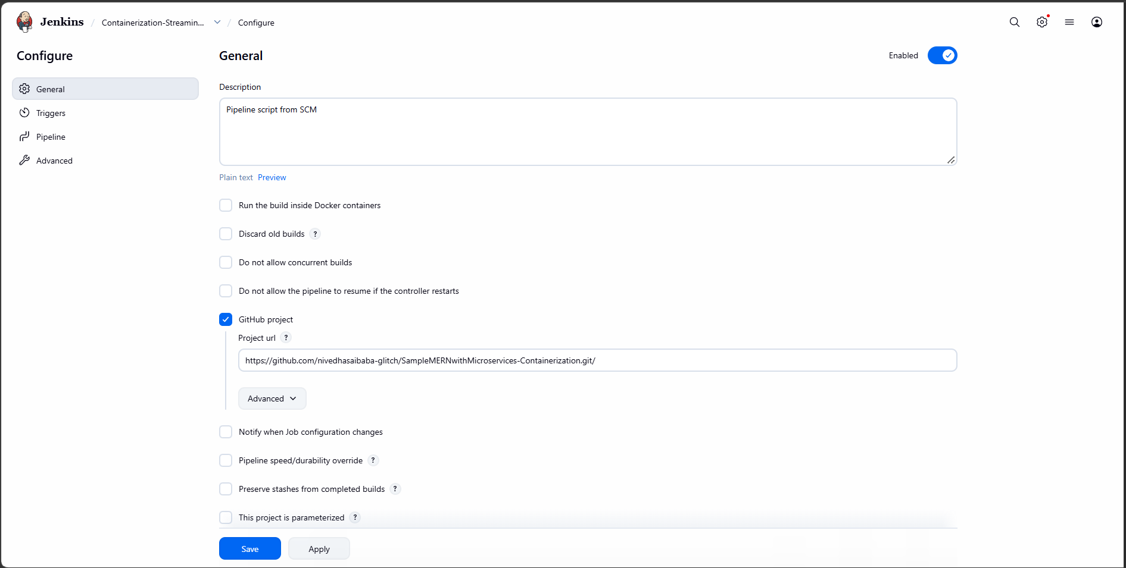
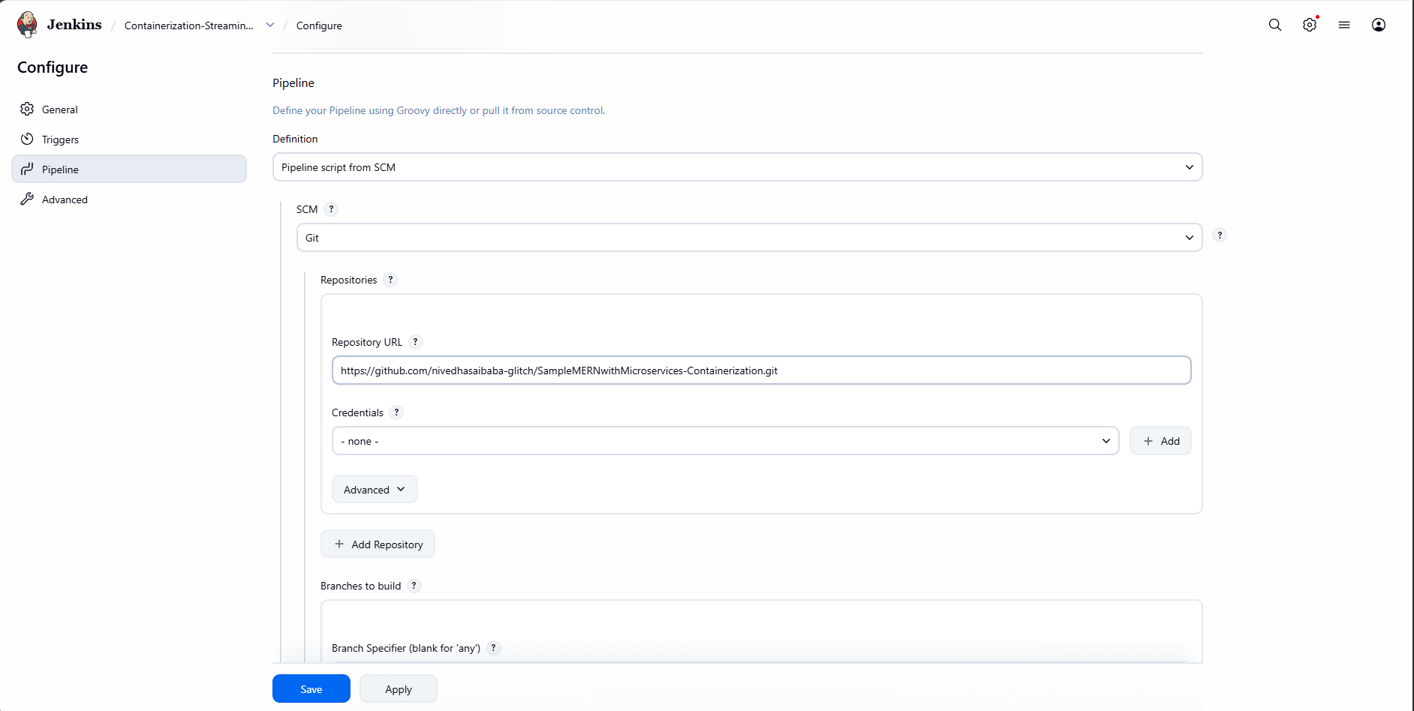
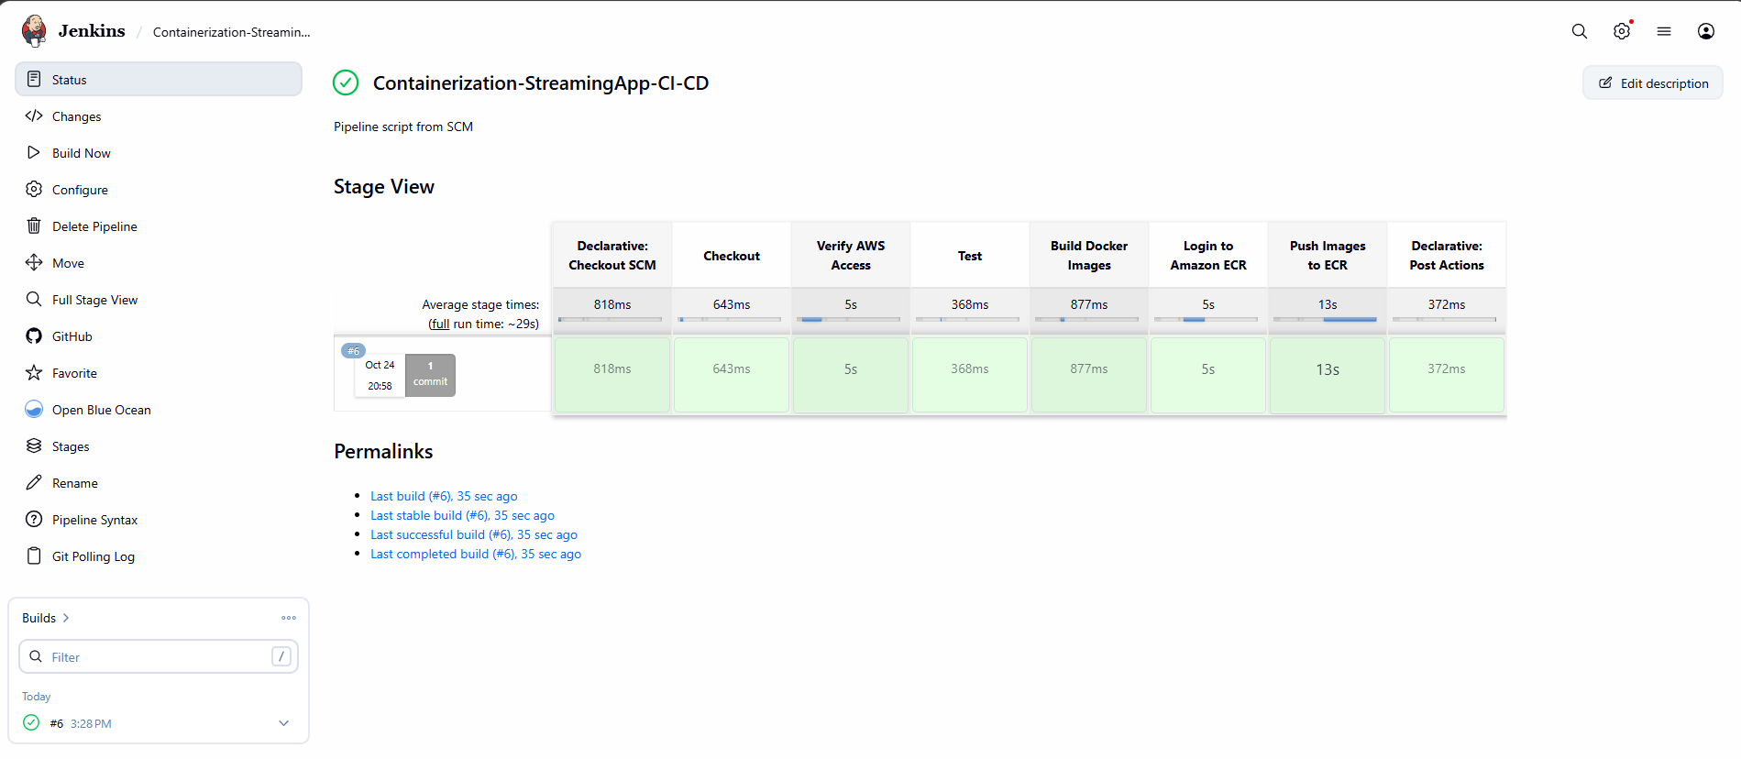
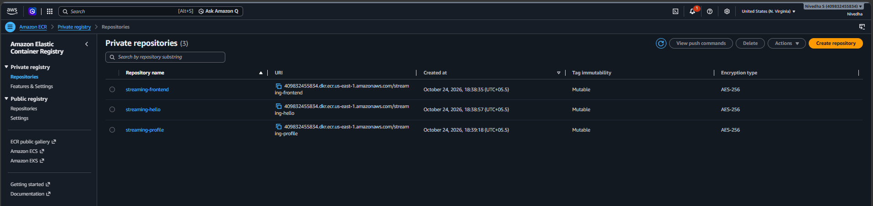
- Create VPC & EKS cluster:
VPC:
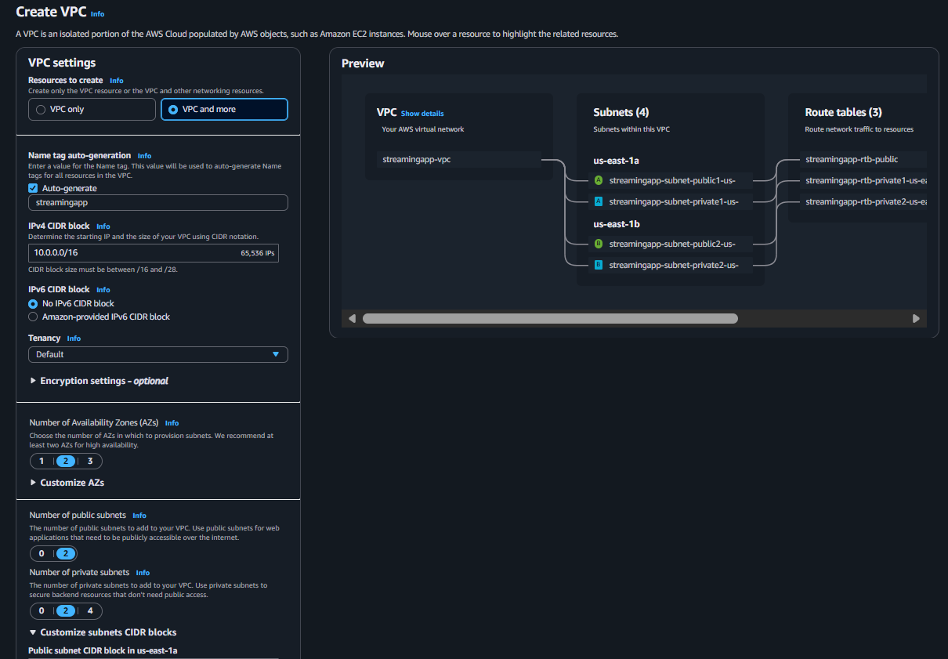
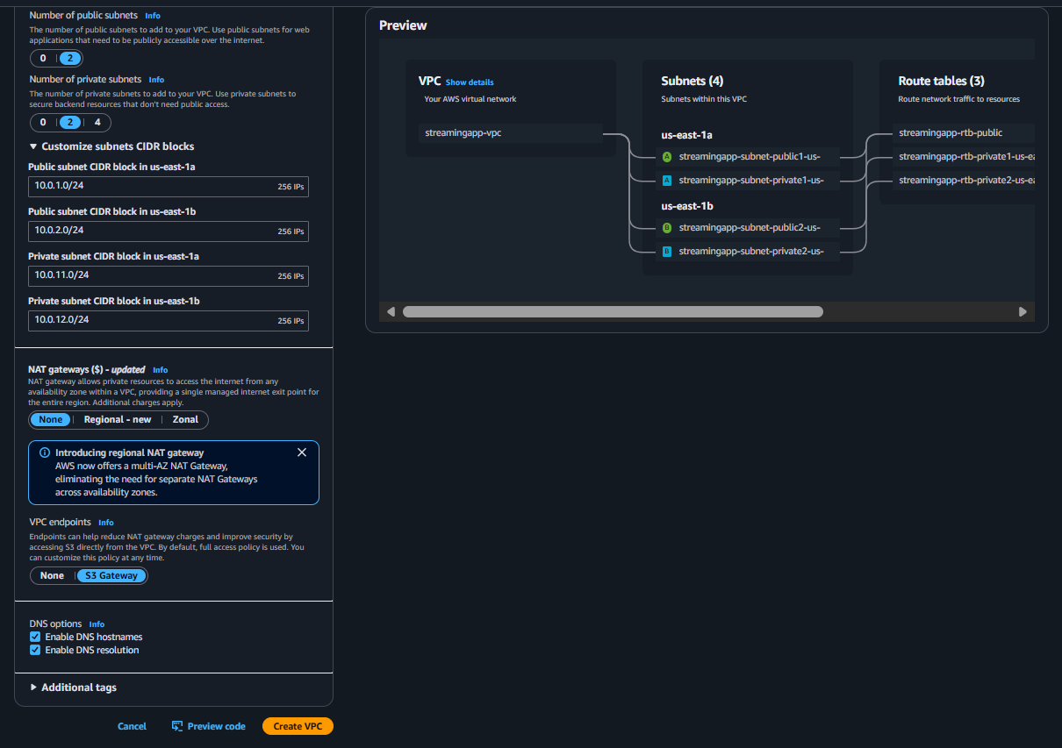
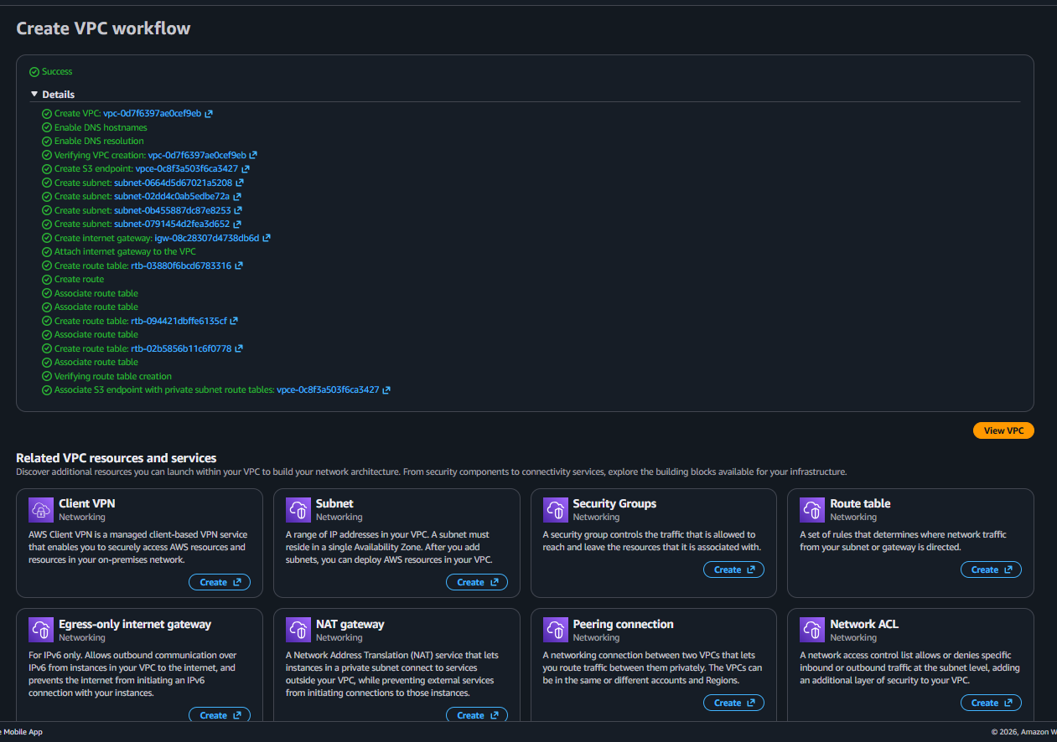
EKS:
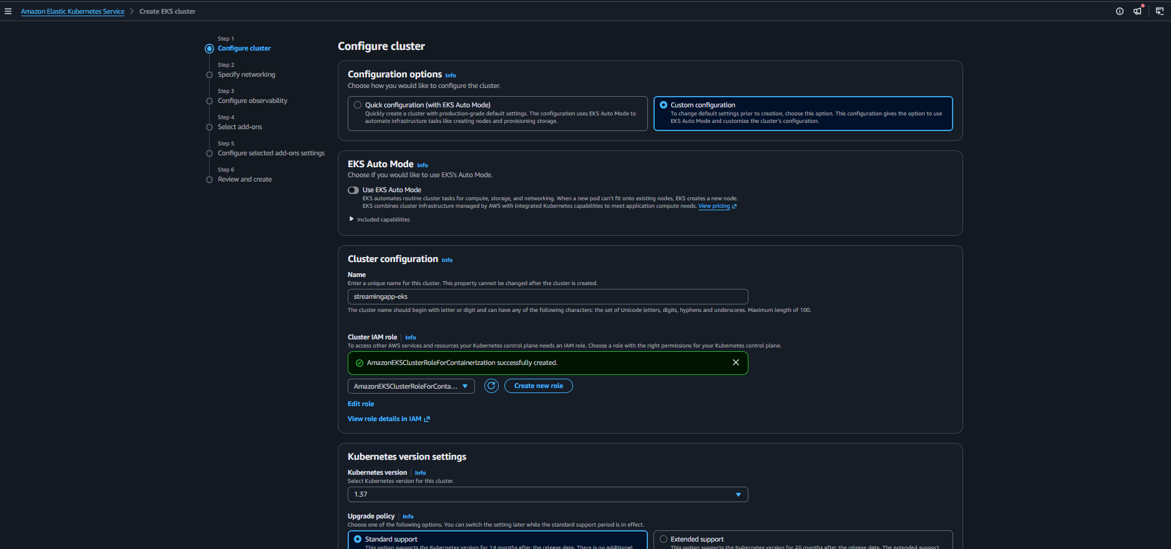
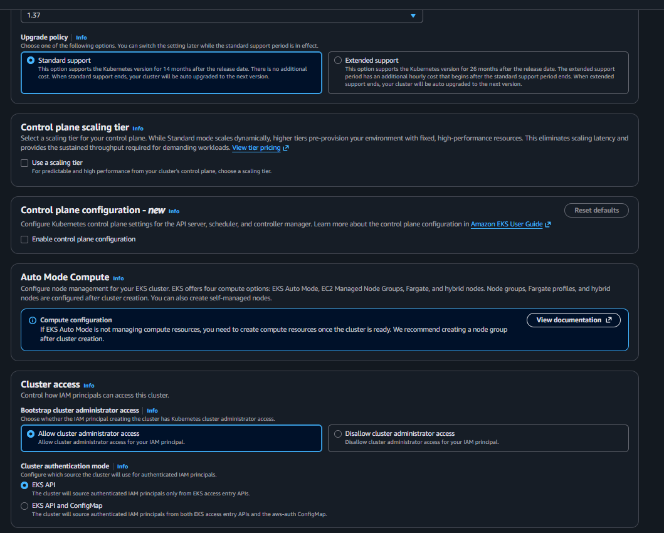
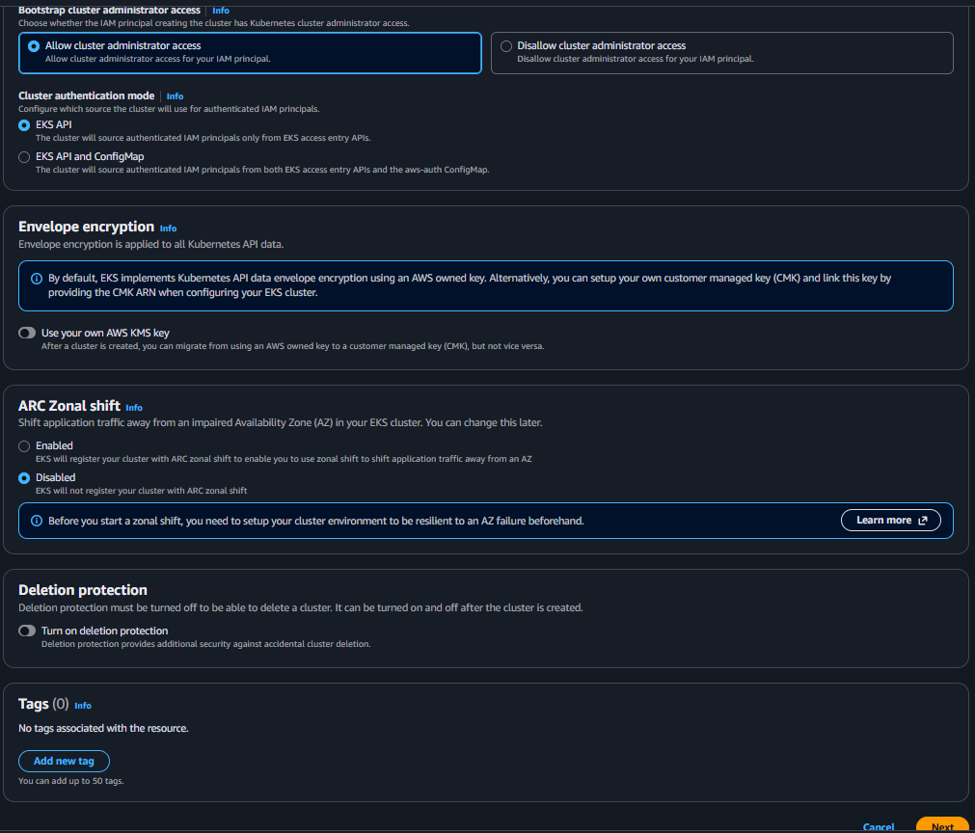
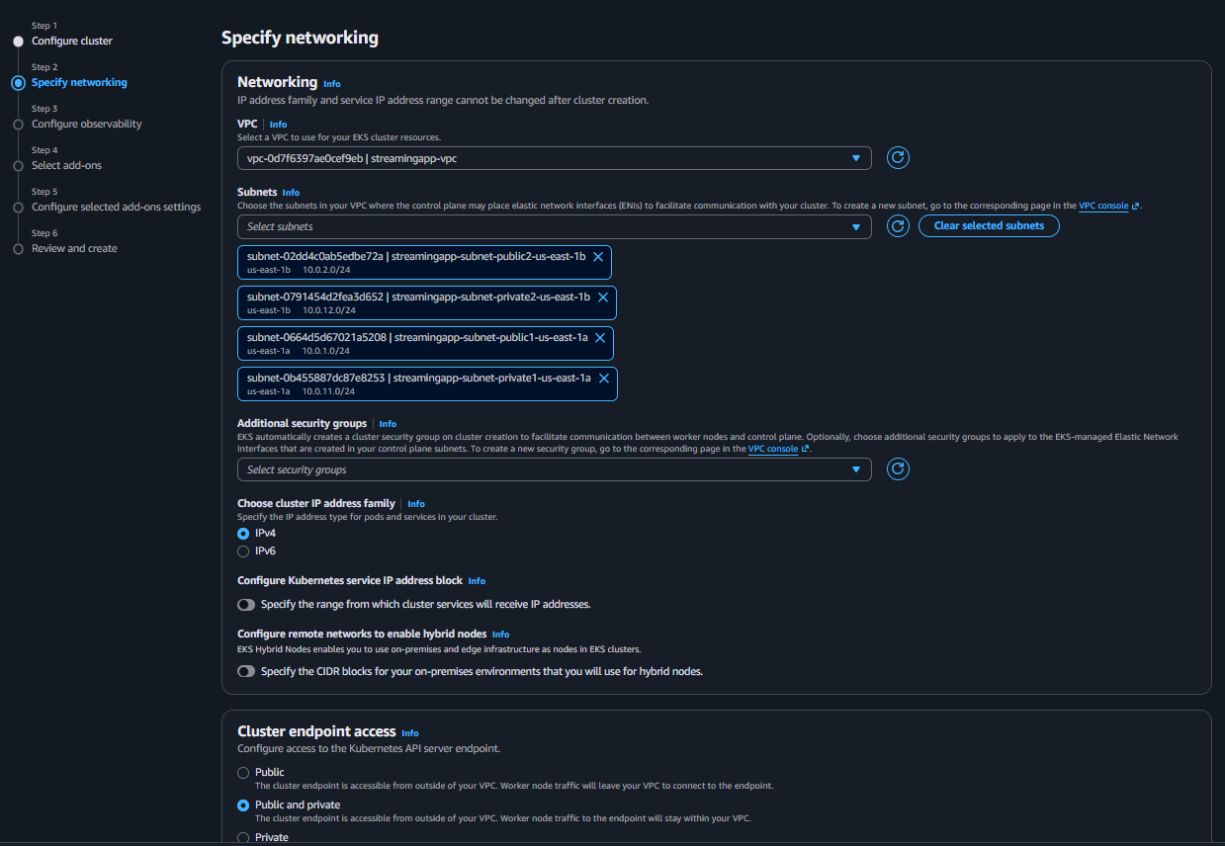
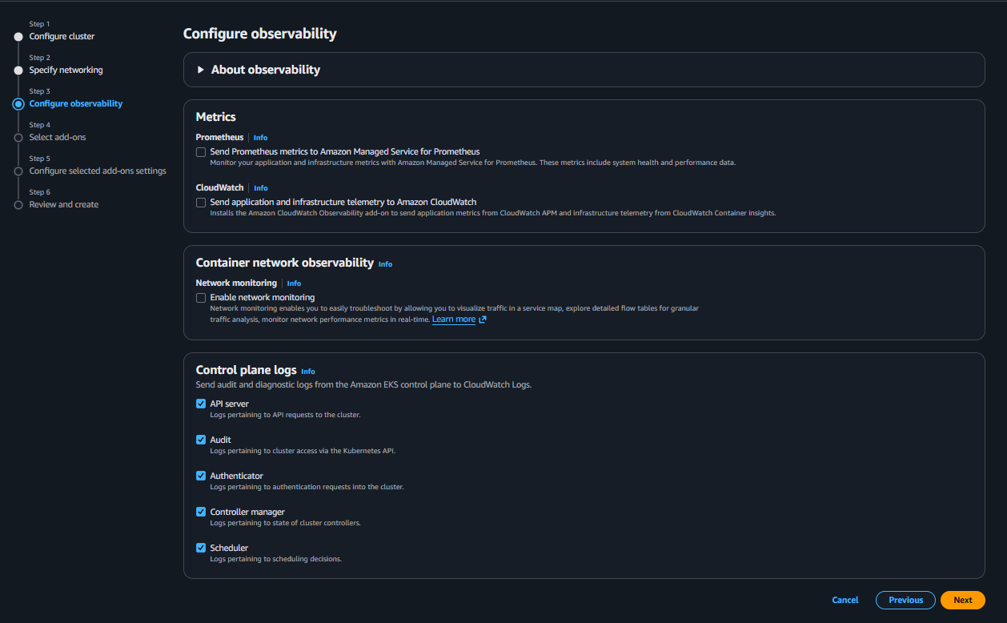
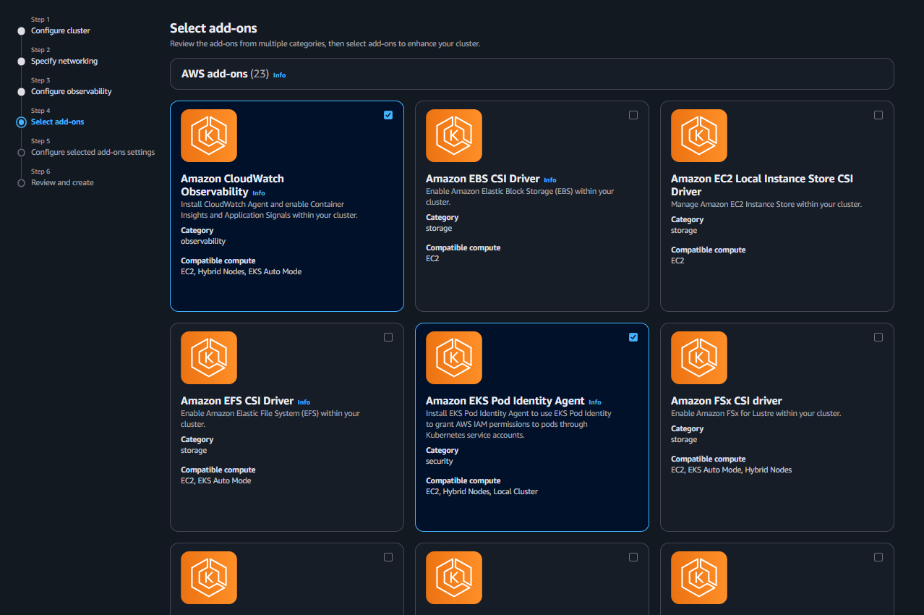
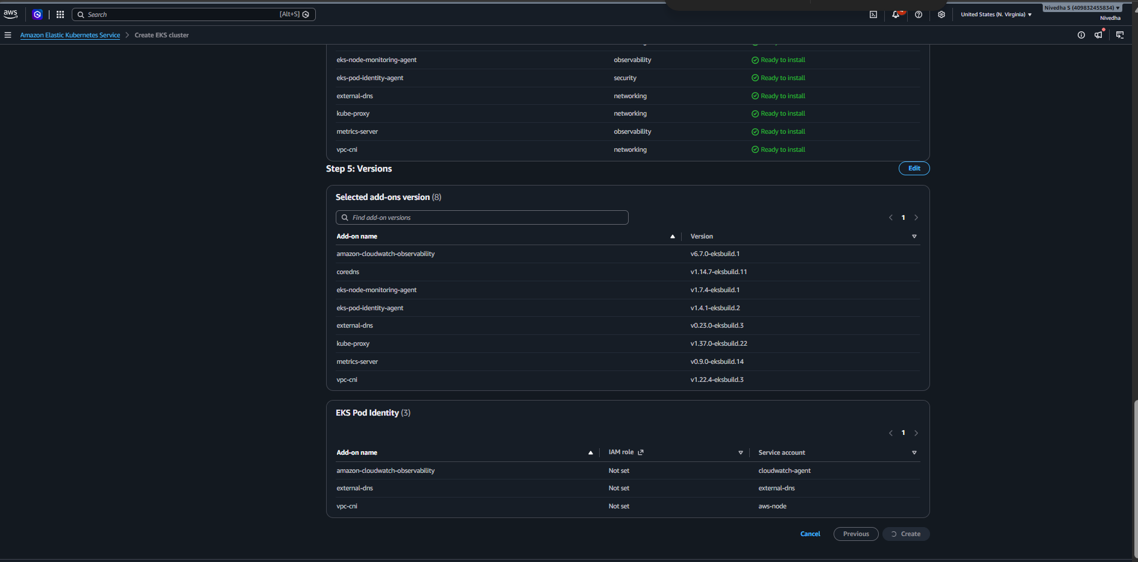
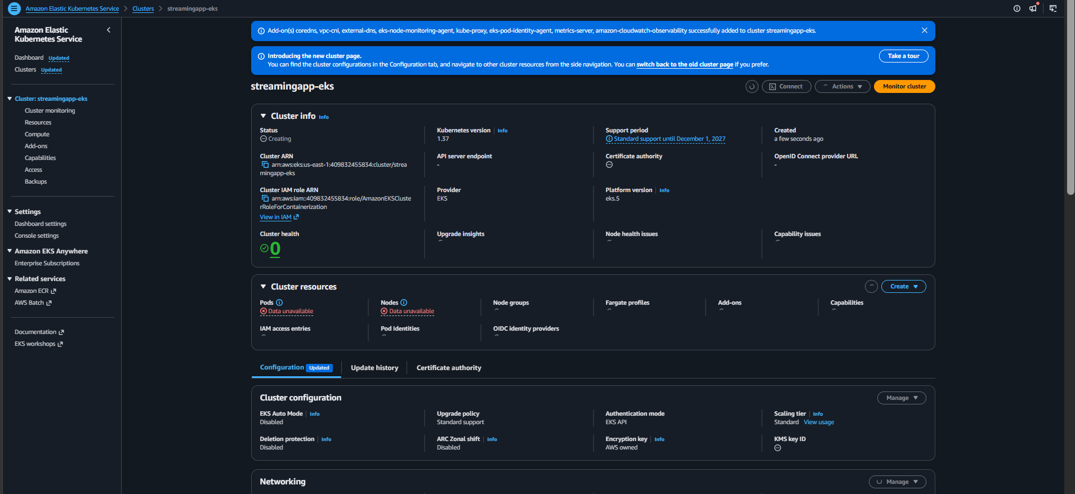
- Create the EKS managed node group:
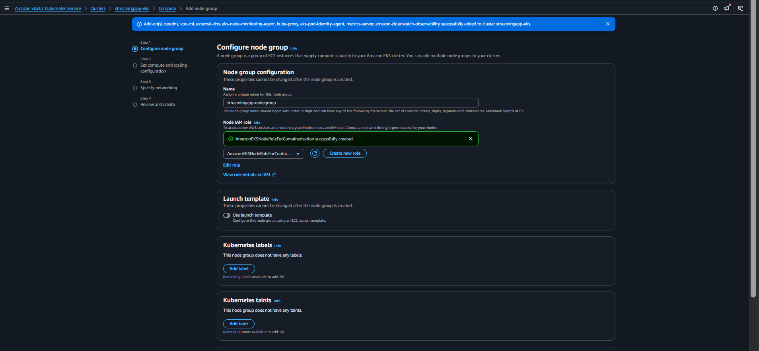
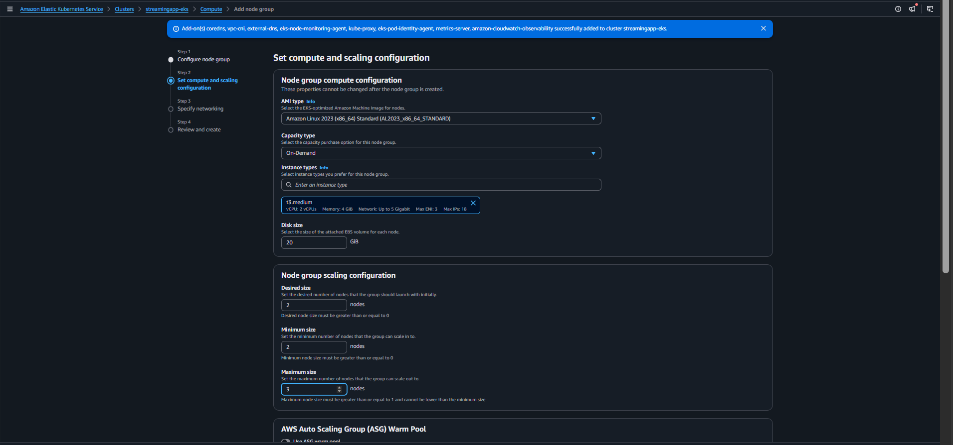
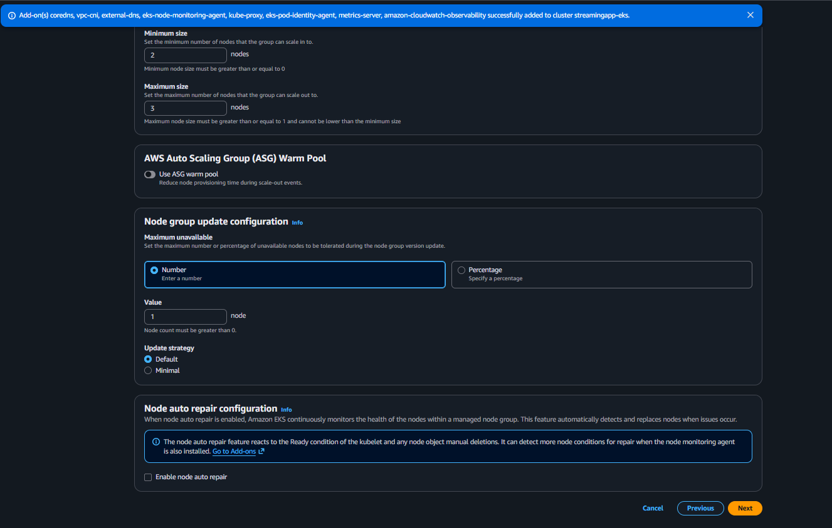
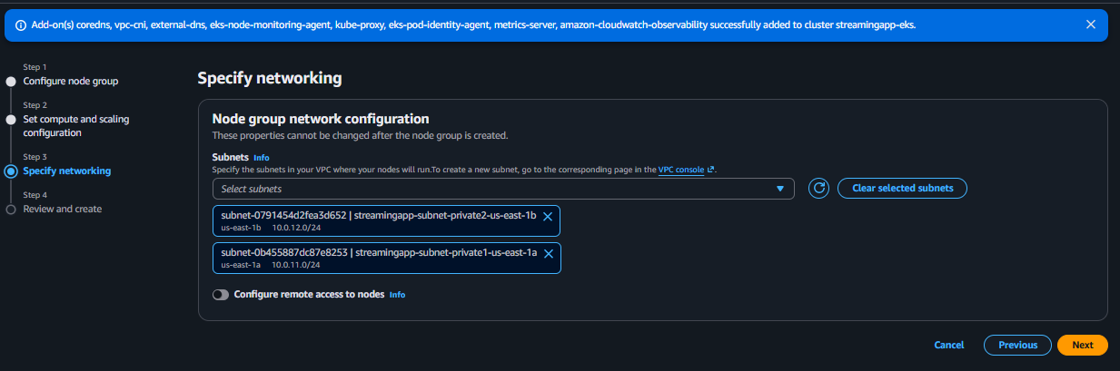
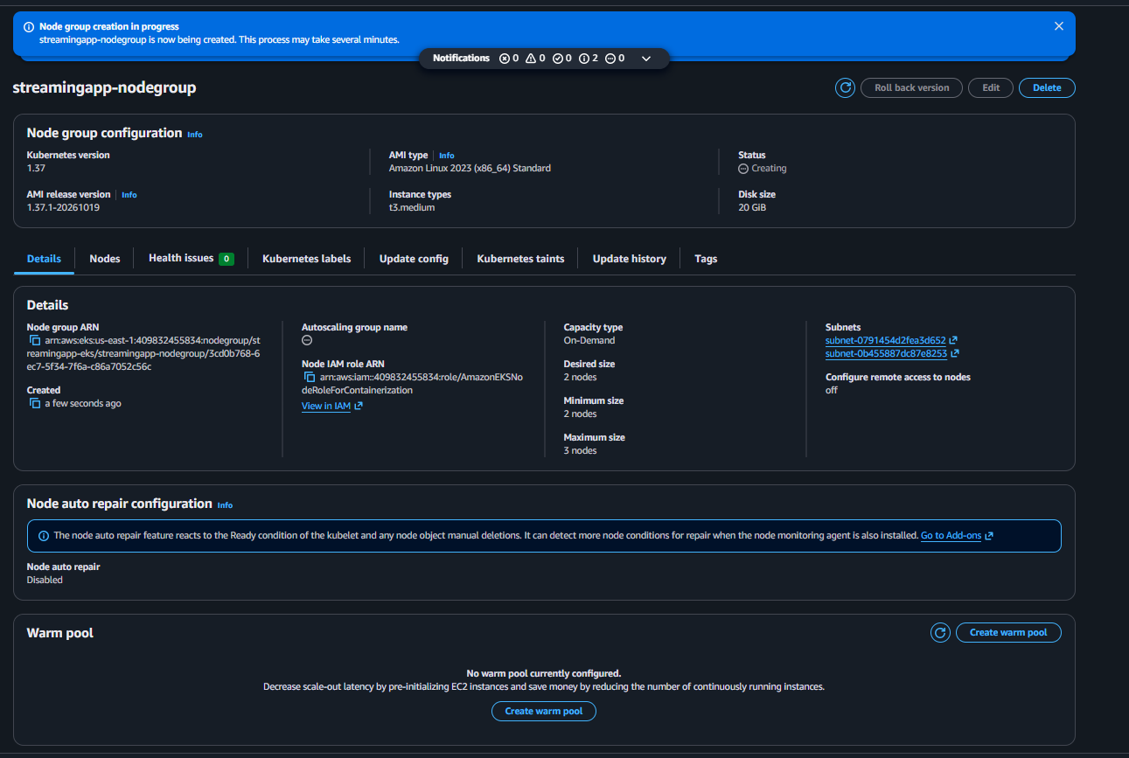
- Create helm chart:
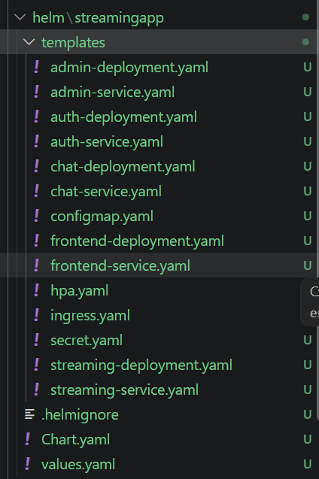
- Output:
